1. You are given an assignment and receive a spreadsheet. The role will be in the title of the spreadsheet; <School> Administrator, <School> Password Reset Supervisor, <School> Password Resetter or other.

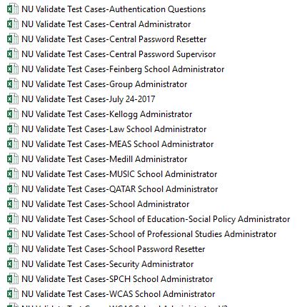

1. When you open the spreadsheet there are several columns.

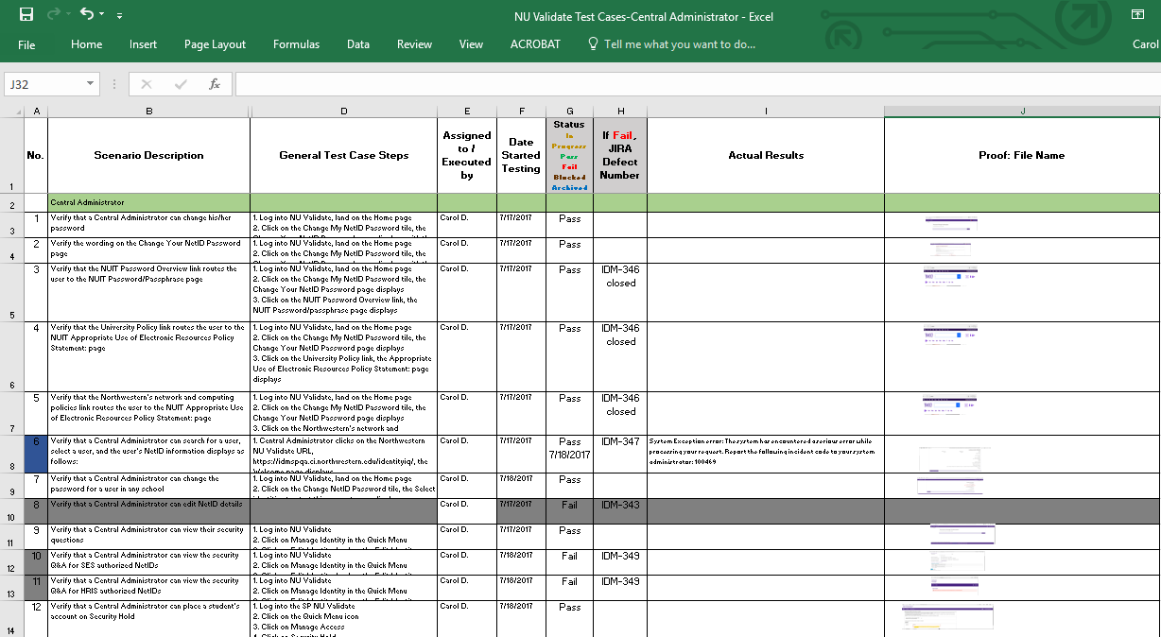

The Scenario Description tells you what needs to be proved.

The General Test Case Steps should be easy to follow. If they need to be adjusted, please send me an email.

Enter your name in the Assigned to / Executed by column.

Enter the Date you begin the test case.

When you completed the test case, enter the status and the actual results. This is very important especially when the test case fails. If you have a failed test case, I will verify it and log a defect in JIRA.

Whether a test case has passed or failed, please get a screen shot of the result and shrink to fit in the cell in the Proof: File Name. If you’d rather create a Word or Excel document, that’s okay too.

There are some test cases that you won’t be executing right away and they are shaded in gray. Most of these test cases failed at the Central Administrator level or need test steps. Once the defect is fixed, I will sent the spreadsheet back to the person to whom the school was assigned, and you will be able to re-test the defect and complete the testing or move to another spreadsheet.

1. **At the end of the day**, send the spreadsheet back to me so I can log the number of test cases executed for statistical purposes and look for any defects you may have found. Once I’ve recorded the numbers, I’ll send the spreadsheet back to you so you can continue testing.
2. Working with users for activation codes – email group DL_NUIT_IQ

